Shell-2010-Pecten-RGBpc.wmf

**Onshore Engineering Nigeria**

**(Operations Support & WRFM)**

**Obigbo NAG Module Optimization Study Report**

Alaka Olanrewaju

Trainee Process Engineer

June 2017

Revision Number: A01

Document Number: **SPDC-2017-04-00000093**

This document is made available subject to the condition that the recipient will neither use nor disclose the contents except as agreed in writing with the copyright owner. Copyright is vested in Shell Petroleum Development Company Ltd. © All rights reserved. Neither the whole nor any part of this document may be reproduced or distributed in any form or by any means (electronic, mechanical, reprographic, recording or otherwise) without the prior written consent of the copyright owner.

Up to two lines if required

Security Classification: Restricted

Security Classification: Restricted

**Revision History**

|  |  |  |  |  |  |
| --- | --- | --- | --- | --- | --- |
| **REVISION STATUS** | | | **SIGNATORIES** | | |
| **Rev.** | **Date** | **Description** | **Originator** | **Reviewer** | **Approver** |
| R01 | May 2017 | Issued for Review | A. Olanrewaju | B. Rasheed |  |
| A01 | June 2017 | Issued for Approval | A. Olanrewaju | B. Rasheed | Y. Ali |
|  |  |  |  |  |  |
|  |  |  |  |  |  |
| * Preliminary issue will be issued as P01 * Revisions for review will be issued as R01, with subsequent come as R02 etc. * Revisions approved for Implementation/Design Issue/Eng. will be issued as A01, with subsequent come as A02 etc. * Revisions approved for Tender will be issued as T01, with subsequent come as T02 etc. * Revisions approved for Construction (AFC)/Purchase will be issued as C01; with subsequent comes as C02 etc. * Highlights of sections revised from previous approved issues or reasons for version change are to be listed in the description box * All revisions to this document must be signed by the relevant Technical Authority (TA1, TA2 or TA3) | | | | | |

**Signatures for this revision**

|  |  |  |  |
| --- | --- | --- | --- |
| **Role** | **Name** | **Signature** | **Date** |
| **Originator** | Alaka Olanrewaju |  |  |
| **Reviewer** | Burahimo Rasheed |  |  |
| **Approver** | Yoo Ali |  |  |

**Contributors:**

**Ojemeni, Kenechi Senior MCI Engineer, Discipline Lead MCI**

**Table of Contents**

Abbreviation 4

1. INTRODUCTION AND BACKGROUND 5

2. FORECAST AND FACILITY REVIEW 9

3. DISCUSSION OF RESULTS 14

4. CONCLUSION 15

5. RECOMMENDATIONS 16

6. REFERENCES 17

Security Classification: Restricted

# Abbreviation

DEG Di-ethylene Glycol

FWKO Free Water Knock-out

JT Joule Thompson

LCV Level Control Valve

LTS Low Temperature Separator

MMscfd Millions Standard Cubic Feet per Day

NAG Non Associated Gas

PCV Pressure Control Valve

PEFS Process Engineering Flow Scheme

# INTRODUCTION AND BACKGROUND

The Obigbo field is located onshore some 18 km north-east of Port Harcourt in the eastern part of the Niger delta. The field was discovered in October 1963 by an exploratory well Obigbo North – 01. To date, the field has been developed by 53 wells, with a total of 77 drainage points. Oil production from the field commenced in October 1965.

The field contains 66 identified reservoir blocks, of which 55 are oil bearing and 11 are gas bearing. The major NAG reservoirs in the field are C6000A, C8000A, and D4000A, with production mainly from wells Obigbo North 43 (C6000A), 44 (C8000A) and 46 (D4000A).

The Obigbo NAG plant was commissioned in 1984 with the purpose of dewpoint the NAG Well fluids to a temperature of about 10oC, separating any condensate liquids and exporting the dried gas into the eastern Domgas network in Nigeria. An Auto-refrigeration via the LTS process is employed to chill the gas, or in other words, the pressure of the gas is reduced and due to the Joule-Thompson (JT) effect, the gas cools. Hydrate formation within the process is mitigated via glycol injection and subsequent regeneration.

The plant has two (2) Modules each with design capacity of 45 MMscfd but current production from the facility decline to less than 20 MMscfd restricting the plant to the usage of one Module (Module 1) at a time.

Production forecast (OP16) also shows that the peak expected gas rate is 25 MMscfd and this is less than the design capacity of a Module.

Module 2 has been isolated for some years based on the low utilization as enumerated above. The current realities is to consider an opportunity to isolate and mothball the entire Module so as to reduce maintenance and opex spent on it.

* 1. **Objective**

The objective of the study is to establish the functional requirements to keep in place to revamp, mothball or decommission the abandoned Obigbo NAG Module 2 .

* 1. **Scope of Review**

The scope of review comprises the following:

* Site visit for physical assessment and as-built verification of the abandoned Module 2.
* Review of the production forecast and potentials for Obigbo NAG plant.
* Review of the mechanical integrity and UT result of the abandoned Module 2.
* Review of the facility operating envelope and capacity checks.
* Feasibility report on what option to progress; revamping, mothballing or decommissioning.
  1. **Obigbo NAG Process Description**

Figure 1-1 below gives a schematic overview of the Obigbo NAG process as narrated in the introductory passage of this report. The main processing unit are Gas handling, Liquid handling, and glycol regeneration. The details is given below.

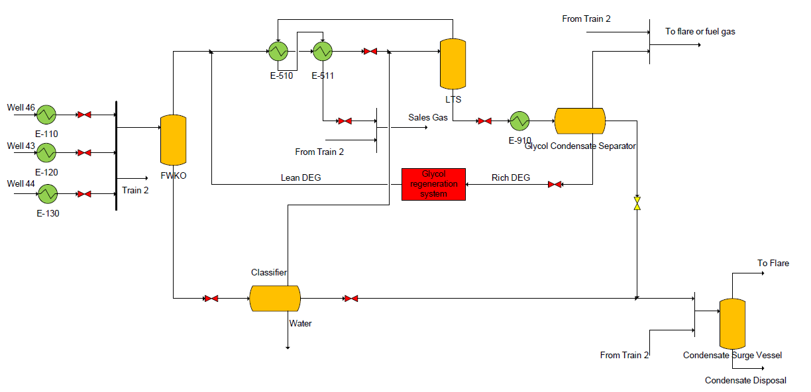

Figure 1-1: Obigbo NAG Plant Process Flow Diagram

**Gas Handling**

Well, stream NAG saturated with water at 104 bar is transported via flowlines from wells 43, 44 and 46 to the plant inlet manifold. If required, the three Well streams are heated to a temperature of 43.5oC in a flowline gas-water heat exchanger to melt any hydrates that may have formed.

**Liquid Handling**

Liquid from the FWKO which is mainly water and a small amount of condensate is routed to the classifier which operates at the same pressure as LTS vessel (~60 bar). Any vapours that are flashed off in the classifier are sent back to the gas train and the liquids proceed to the condensate surge vessel. Substantially more hydrocarbon liquid along with the glycol-water solution is generated in the LTS vessel due to gas chilling. The glycol-condensate mixture from the LTS vessel is routed to a three-phase glycol-condensate separator operating at 11 bar and 27oC. The condensate from this separator is mixed with liquid from the FWKO and sent to the surge vessel. The flash gas is either used as fuel or flared. The glycol-water solution (also known as rich glycol) is routed to the glycol regeneration system.

The condensate is stabilized for export via the surge vessel which reduces its pressure to around 1.5 bar. The offgas from the surge vessel is flared while the stabilized condensate is mixed with oil from the flowstation and exported to the Bonny terminal. Figure 1-1 provides an overview of the condensate handling system.

**Glycol Regeneration System**

The purpose of the glycol regeneration system is to remove the water from the glycol solution which dropped out owing to gas dewpointing.

The rich glycol stream from the glycol condensate separator is flashed to atmospheric pressure and then heated using the rich glycol - lean glycol exchanger and glycol reboiler to a temperature of around 90oC. This heating allows water to be boiled off from the rich glycol solution in the glycol reboiler column. Water vapour is discharged locally to the atmosphere. The resulting lean glycol which is at 75 % glycol by weight and ~110oC is cooled using rich - lean glycol exchanger to around 45oC and sent to the glycol accumulator which acts as buffer storage for glycol in the system. The glycol is then pumped from the accumulator into the gas train upstream of the gas-gas exchanger at ~100 bar using the glycol injection pumps.

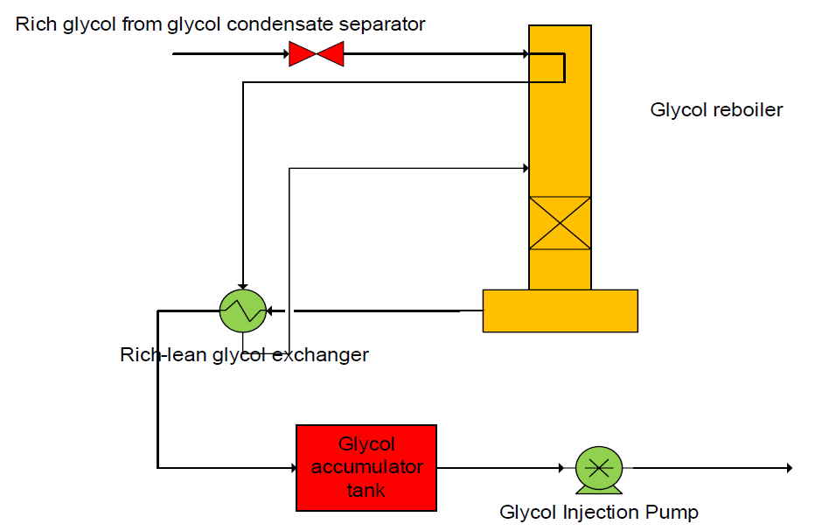

Figure 1-2: Glycol Regeneration System Process Flow Diagram

# FORECAST AND FACILITY REVIEW

* 1. **Optimization Study Methody (Cadence and WAVE Tool)**

The optimization study was done via a multidisciplinary effort using Cadence and WAVE tool as a means to track and follow up on all actions required for speedy project completion.

The agreed work scope and timeline used for the study is summarized below:

Table 2-1: Obigbo Module-2 Optimization Workplan

|  |  |  |  |
| --- | --- | --- | --- |
| **S/N** | **Project Scope/Action** | **Action Party** | **Due Date** |
| 1 | Formation of an interdisciplinary project team | Burahimo Rasheed | 13th March 2017 |
| 2 | Review of the production forecast and potentials for the facility | Dipo Ashafa | 15th March 2017 |
| 3 | Creation of project schedule and planning | Burahimo Rasheed | 15th March 2017 |
| 4 | Get estimates of module-1 maintenance cost and OPEX spend on hydrate control system | Burahimo Rasheed | 17th March 2017 |
| 5 | Update Charter with cost estimates and revised project scope | Burahimo Rasheed / Alaka | 17th March 2017 |
| 6 | Data gathering and preliminary review/analysis | Burahimo / Alaka / Oyenuga | 24th March 2017 |
| 7 | Develop process simulation model for the facility to review requirement for hydrate control system | Alaka Olanrewaju | 24th March 2017 |
| 8 | Engage Technical authorities and obtain buy-in | Burahimo Rasheed | 24th March 2017 |
| 9 | Interdisciplinary site visit for integrity assessment | Burahimo / Oyenuga / Omonigho / MCI | 29th March 2017 |
| 10 | Review of the facility operating envelope and capacity checks | Burahimo / Alaka | 7th April 2017 |
| 11 | Review of the status of all module equipment/units | Burahimo / Oyenuga / Omonigho / Alaka / Ojemeni | 14th April 2017 |
| 12 | **Issuance of interdisciplinary optimization report** | Burahimo Rasheed / Alaka / Ojemeni | 9th June 2017 |

The initiative progressed from L0 to L3 gates in the WAVE tool and action plans for detailed execution of the recommendations from this report will progress the initiative to L5 (closeout report).

* 1. **Review of Obigbo NAG Production Forecast**

The production forecast (OP2016) for Obigbo NAG is given below. The data represent the cumulative production expected from all the Wells feeding the plant throughout the life of the facility.

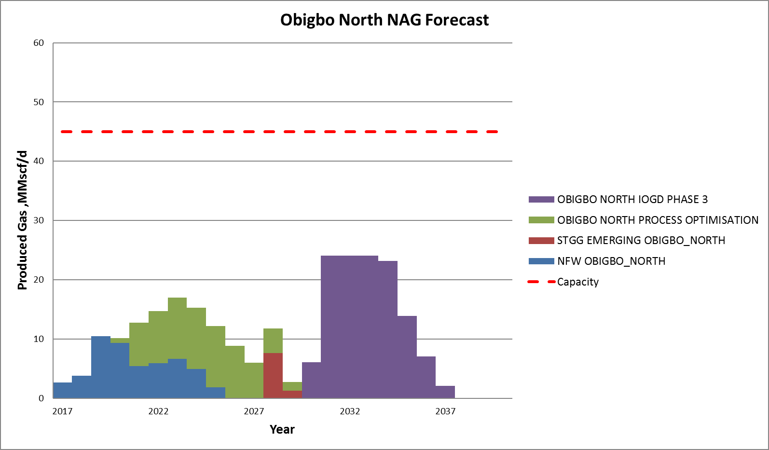

Figure 1-3: Obigbo North NAG Production Forecast

The profile shows that the peak expected production from the Wells is 24 MMscfd between Y20131 and Y2034. The profile has considered all possible development within the OP16 tied to the NAG plant.

* 1. **Review of the Operating Envelope and Capacity Check for Module-1**

The Obigbo NAG plant modules are designed for a nominal throughput of 45 MMscfd based on the dewpoint requirement of the plant and inlet manifold pressures. The plant has three main processes as defined in section 1.2 and this forms the basis of the operating limits of the facility.

The main components of the gas handling system are the Low Temperature Separator (LTS) vessels, Free Water Knock-out (FWKO) vessel and the gas/gas heat exchangers.

The limiting capacities of the vessels are defined by their vessel handling capacities based on fluid properties obtained from the process simulation developed for the facility and design rules from DEP 31.22.05.11-Gen. The gas-gas exchangers were rated based on the momentum and Reynold’s number criteria for the shell and tube nozzles.

The results of the sensitivity analysis done on Module-1 shows the ability of the train to achieve the dewpoint as a function of the sales gas pressure, required hydrocarbon dewpoint and gas inlet temperature. The results obtained are summarized below:

Table 2-1: Capacity Check for Obigbo NAG Module-1

|  |  |  |
| --- | --- | --- |
| **Inlet Pressure = 100 barg** | | |
| **Sales Gas Pressure, barg** | **Rate Module Capacity, MMscfd** | **Limiter** |
| 50 barg | 35 | LTS Vessel |
| 60 barg | 40 |
| 70 barg | 42 |

The limiting equipment in the module is the LTS vessel and the capacity can be further optimized by reducing the liquid level in the vessel.

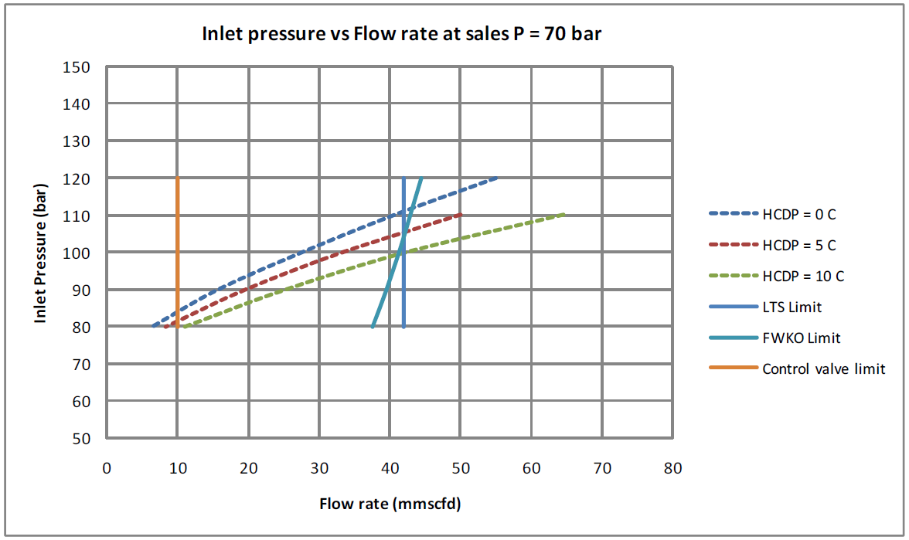

Figure 2-1: Sensitivity result for the Module-1 at inlet pressure of 100 barg and sales pressure of 70 barg

* 1. **Review of the mechanical integrity of the Module-2**

An integrity assessment of the Obigbo NAG facility – Module-2 is required to determine the fitness for service of selected equipment in the plant which is intended to be used as spares for module-1.

* + 1. **Assessment Scope**

Equipment of interest include separators, two heat exchangers, valves, and flanges. Piping, structural members, and other sundry items are not included. This assessment will provide the required information to determine which items are in good condition. It will also highlight further activities to be carried out before deploying the equipment.

* + 1. **Assessment Methodology**

The following activities have been carried out as part of this assessment;

Table 2-2: Primary Assessment Activities

|  |  |  |  |
| --- | --- | --- | --- |
|  | **ACTIVITY** | **ACTION PARTY** | **REMARK** |
| 1 | Wall Loss Measurements | Maintenance Team | Used as screening data |
| 2 | HYDROCOR Simulation | Materials & Corrosion | Identify high risk (internal) areas |
| 3 | Visual Inspection | Materials & Corrosion | Identify high risk (external) areas |
| 4 | Intrusive Inspection | Maintenance Team | Identify high risk (internal) areas |

* + 1. **Assessment Results**

Table 2-3: Simulation and UT wall Loss Results

|  |  |  |  |  |
| --- | --- | --- | --- | --- |
| **STREAM** | **ITEMS** | **HYDROCOR** | **INSPECTION** | |
| **Equipment** | | | | |
|  |  | Corrosion Rate (mm/y) | Intrusive | UT Wall Loss (mm) |
| 8 | Heat Ex E-320 | 0.22 | DONE | UA |
| 11 | Inlet/Sales Gas Heat Ex E-521 | 0.21 | DONE | UA |
| 10 | Glycol / Cond Water Heat Ex E-910 | 0.04 | DONE | 1 |
| 14 | Classifier V-420 | 0.37 | DONE | 0 – 0.05 |
| 4 | FWKO V-320 | 0.27 | DONE | 0 – 0.05 |
| 42 | LTS V-720 | 0.07 | DONE | 0 – 0.05 |
| 48 | Glycol Cond Sep V-1010 | 0.05 | DONE | UA |
| 5 | Cond Surge Vessel V-1100 | 0.01 | DONE | UA |
| **Valves** | | | | |
| HP Liq. | VLV-105 | 0.22 | NOT DONE | NA |
| 19 | VLV-106 | 0 | NOT DONE | NA |
| 17 | VLV-102 | 0.16 | NOT DONE | NA |
| 39 | VLV-107 | 0.13 | NOT DONE | NA |
| 15 | VLV-101 | 0.08 | NOT DONE | NA |
| 16 | VLV-108 | 0.01 | NOT DONE | NA |
| 31 | VLV-109 | 0 | NOT DONE | NA |
| 2 | VLV-110 | 0.01 | NOT DONE | NA |
| **Miscellaneous** | | | | |
|  | Flanges | Visual inspection carried out | | |

*UA – Unavailable NA – Not Applicable

# DISCUSSION OF RESULTS

The review of the production profile shows that the peak rate from all possible development into the Obigbo NAG plant from OP16 is 25 MMscfd which dwarfs the nominal design capacity of each NAG module (45 MMscfd).

The review of the operating envelope and capacity checks for a single module shows that at current operating condition (manifold pressure of 100 barg and sales pressure of 70 barg), the capacity of a module is 42 MMscfd which is limited by the LTS vessel gas handling capacity. The value reduces for every reduction in sales gas pressure but this is supplemented by an improved hydrocarbon dewpoint.

For latter life (reduction in Wells and inlet manifold pressures), the capacity of the LTS vessel is predicted to reduced to 35 MMscfd at inlet pressure of 70 barg. This can be optimized through a reduction of the liquid level setting in the vessel.

Overall, the results from all sensitivities show that the current and expected capacities at latter life of a module is higher than the expected peak production from the NAG plant.

Also, the Hydrocorr simulation results show relatively significant internal corrosion in 40% of the equipment. However, further intrusive inspection was carried out which showed significant internal corrosion in the glycol condensate separator and some heaters, most of which are not within the scope of this report. Thus, based on the available inspection results and simulation, the listed equipment in Table 3-1 below are in good condition.

Table 3-1 Summary of the equipment condition

|  |  |
| --- | --- |
| **ITEMS** | **EQUIPMENT CONDITION** |
| Heat Exchangers | Shell in good condition. Tubes to be replaced. |
| Glycol / Cond Water Heat Ex E-910 | Good. |
| Classifier V-420 | Good. |
| FWKO V-320 | Good. Repair damaged manhole davit |
| LTS V-720 | Good. Repair damaged manhole davit |
| Glycol Cond Sep V-1020 | Good. Active internal corrosion. |
| Cond Surge Vessel V-1100 | Good. |
| Flanges | Good. |
| Valves | Good. Recertify before use. |

Prior to deployment, further activities are required to determine the remaining life and IOW of the equipment.

# CONCLUSION

The Obigbo NAG facility has two modules each with a design capacity of 45 MMscfd with current production rate of <12 MMscfd thereby restricting the facility to the usage of one module at a time.

Production forecast shows that the peak expected gas rate from OP16 forecast is 24 MMscfd after considering all possible development into the facility and this is less than the nominal design capacity (45 MMscfd) of a module. The review of the operating envelope and capacity checks for the major module equipment shows that the minimum (35 MMscfd) capacity of the facility expected at facility later life is still higher than the expected peak production and only one Module will be needed in operation throughout the facility life.

The corrosion simulations and UT results show that the vessels and heat exchangers are in relatively good conditions and can be mothballed and shipped to Kidney Island for storage and use by other assets or new projects. The valves are also in good conditions based on physical assessment but function tests should be done to confirm that they are in good condition and then isolate and safekeep as spare parts for Module-1.

The estimated cost of the equipment available as spares for Module-1 and vessels to be shipped and mothballed to KI is $ 5.6 million (with 50% depreciation factor).

# RECOMMENDATIONS

Based on the outcome of the optimization study, the following are recommended:

1. The NAG plant Module-2 should be isolated and decommissioned with all its equipment and accessories.
2. The vessels, exchangers, and other accessories should be mothballed, preserved and shipped to KI for use by other Assets or Projects.
3. The valves (LCV, TCVs, JT-valves etc.) should be function tested and kept as spares for Module-1
4. Conduct intrusive inspection of the valve internals to confirm the integrity of the internals.
5. Conduct a non-destructive inspection of the welds, nozzles, and cladding.
6. For safe keeping, remove all corrosion products and scale before re-coating all the vessels and equipment.
7. Rebuild lost / corroded metal sections via welding and grinding techniques. Ensure rebuilt sections are inspected to ensure structural integrity.
8. Prior to storage - all equipment, valves, and flanges should be preserved and fully wrapped before transport to warehouse locations.
9. Details such as the MWP, MTP, Design Temperature (Shell/Tube) and size should be captured in the final inspection report to be issued by the maintenance team. Future users of these equipment should never exceed the MWP. All relevant PEFS and Design document should be updated accordingly and a copy keep with the rquipment for future reference.
10. Every effort should be made to define the IOW of each equipment prior to use. A key input to this process is the fitness for service assessment and remaining life calculations.

# REFERENCES

1. GS.09.54603, Obigbo North NAG Plant and Water Injection Plant – Simulation and Operating Envelopes, 2009.